# Photo Card Reflections – Points of You AI Training

**I’m a photo therapist and I use cards with my clients. Suggest me 5 reflections and/or observation I can share with a client who chose this image.**

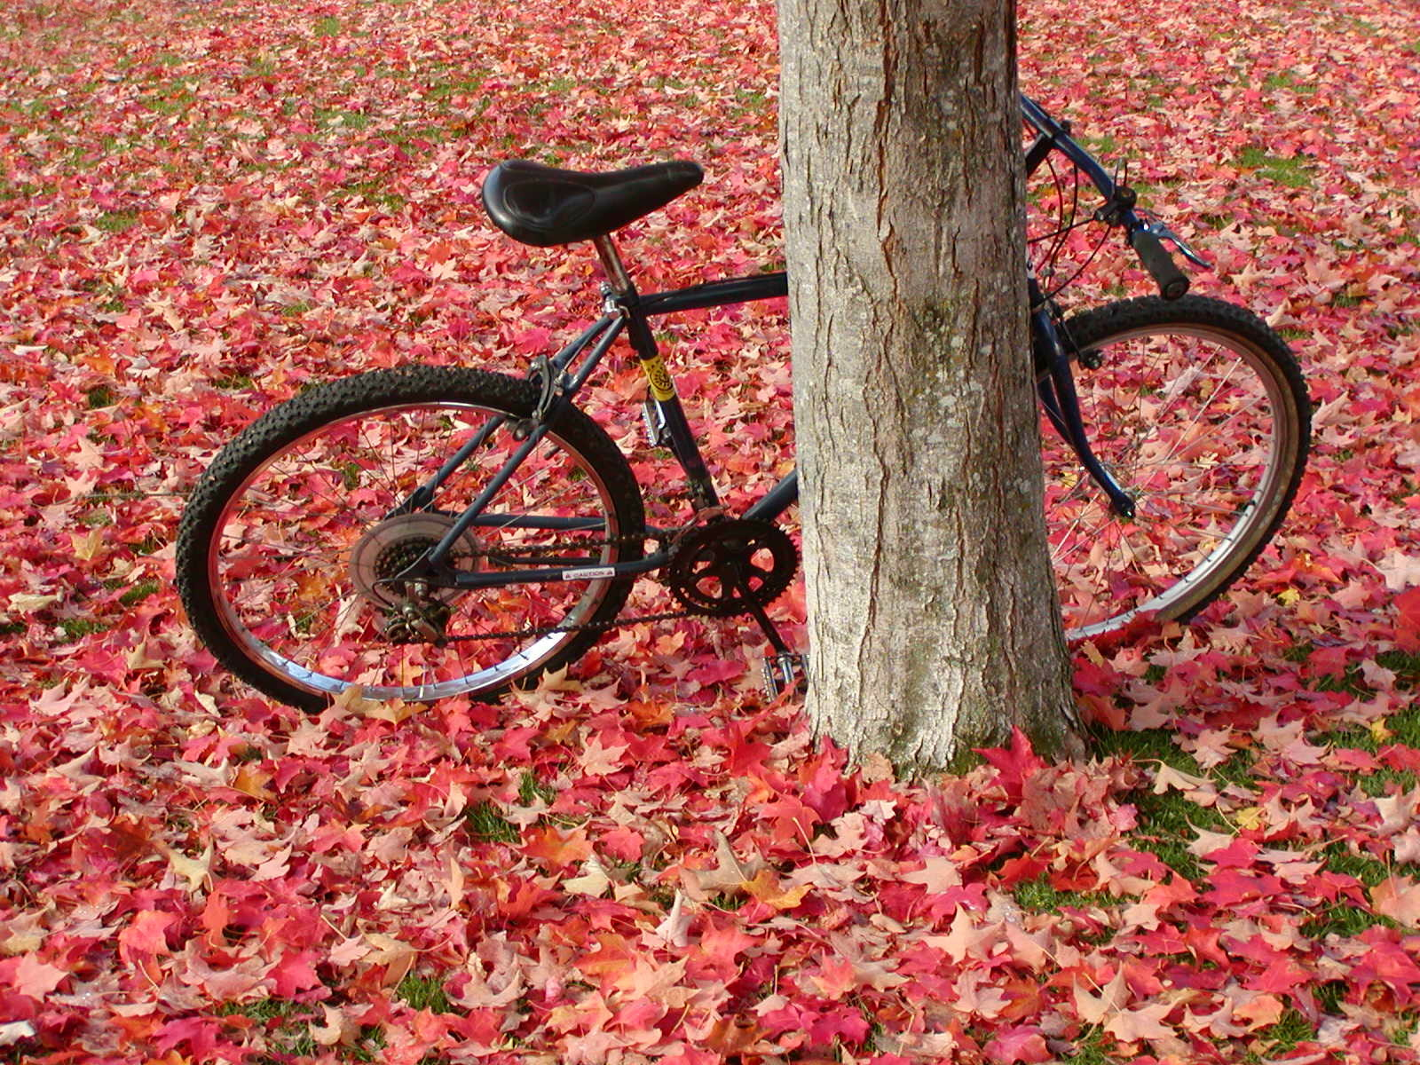

Here are five reflections and observations you can share with a client who chose this image:

1. **Balance and Stability**: The bicycle leaning against the tree can symbolize a need for support and stability. Reflect on the sources of support in your life that help you maintain balance. What or who do you lean on when you need stability?
2. **Hidden Potential**: The bicycle is partially hidden by the tree, suggesting that parts of it are not immediately visible. Consider aspects of your life or personality that might be hidden or not fully expressed. What potential within you is waiting to be uncovered?
3. **Seasons of Change**: The fallen leaves indicate a transition, possibly from autumn. Reflect on the changes happening in your life. How do you feel about the current season or phase you are in, and what changes are you experiencing or anticipating?
4. **Journey and Movement**: A bicycle represents a journey or movement. Think about the journey you are on in life. Where are you headed, and what steps are you taking to move forward? Are there any obstacles or detours you are encountering?
5. **Connection to Nature**: The presence of the tree and the leaves connects the bicycle to the natural environment. Reflect on your relationship with nature and how it influences your well-being. How do you feel when you spend time outdoors, and what can you do to strengthen this connection?

These reflections can help clients explore various aspects of their lives and emotions through the metaphor of the image.

**Now give me 5 reflections and /or observations is I’m a manager and my employee chose this card as part of his role and team assessment**

Sure, here are five reflections and observations tailored for a manager whose employee chose this image as part of a role and team assessment:

1. Support Systems: The bicycle leaning against the tree can symbolize reliance on support systems. Discuss with your employee the sources of support they have within the team and organization. Are there areas where they feel they need more support or resources to perform their role effectively?
2. Visibility and Recognition: The bicycle is partially hidden behind the tree. This could reflect feelings of being unnoticed or underappreciated. Ask your employee if they feel their contributions are recognized. How can the team or organization ensure everyone’s efforts are visible and acknowledged?
3. Adaptability and Change: The fallen leaves indicate a period of change. Engage your employee in a conversation about how they handle change within the team or organization. What recent changes have they experienced, and how have these changes affected their role or team dynamics?
4. Personal and Professional Growth: A bicycle represents movement and progress. Reflect on your employee's career journey and goals. Are they on a path that aligns with their personal and professional aspirations? What opportunities for growth and development can the organization provide to support their journey?
5. Work-Life Balance: The image of the bicycle in a natural setting might suggest a need for balance. Discuss with your employee how they manage their work-life balance. Are there any adjustments or supports that could help them achieve a healthier balance between their professional and personal lives?

These reflections can help you, as a manager, understand your employee’s perspective and identify areas for support and development within the team.

**Now give me 5 more about this photo card**

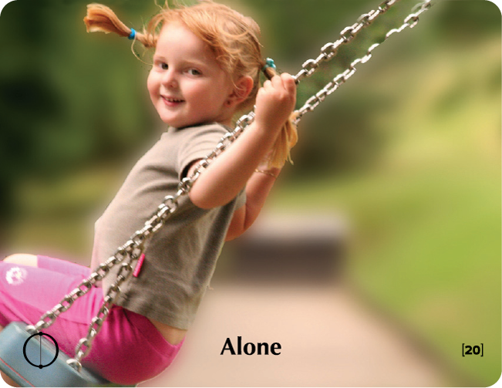

Here are five reflections and observations for this photo card, featuring a child on a swing with the caption "Alone":

For Personal Reflection:

1. Solitude vs. Loneliness: Reflect on the difference between being alone and feeling lonely. How do you perceive solitude? Is it a time for personal reflection and joy, as the child's smile suggests, or does it evoke feelings of isolation?
2. Inner Child: The image of a child swinging alone can symbolize reconnecting with your inner child. Reflect on moments of pure joy and freedom from your own childhood. How can you bring some of that carefree spirit into your current life?
3. Independence: The child appears happy despite being alone, which can symbolize independence and self-sufficiency. Consider how you feel about your own independence. Do you embrace it, or do you sometimes wish for more companionship and support?
4. Present Moment Awareness: The child is engaged in the moment, swinging and smiling. Reflect on your ability to stay present and enjoy the moment. Are there ways you can practice mindfulness to enhance your appreciation of the here and now?
5. Perspective on Alone Time: The caption "Alone" paired with a happy image might challenge your perceptions. Reflect on your feelings about alone time. Is it a chance to recharge and find joy, or do you find it challenging?

For Role and Team Assessment:

1. Self-Sufficiency in the Team: The child’s contentment while alone can symbolize self-sufficiency. Discuss with your employee how they view their role within the team. Do they feel confident and capable when working independently?
2. Perceptions of Solitude: The image can evoke mixed feelings about solitude. Ask your employee how they perceive working alone versus in a team. Do they thrive in solo projects, or do they prefer collaborative efforts?
3. Team Dynamics and Inclusion: The concept of being alone can prompt discussions about inclusion. Reflect on your team’s dynamics. Does everyone feel included and supported, or are there members who might feel isolated?
4. Work Enjoyment: The child’s happiness while swinging alone can lead to discussions about job satisfaction. Ask your employee what aspects of their work bring them joy. Are there tasks or projects they particularly enjoy doing alone?
5. Balance Between Independence and Collaboration: This image can highlight the balance between working independently and collaboratively. Discuss with your employee how they manage this balance in their role. Are there areas where they need more independence or more team interaction?

These reflections can help deepen your understanding of personal feelings or team dynamics, providing valuable insights for personal growth or team development.

**The client chose the 3 photo cards attached. Give me 5 reflections/observations including the relationship between the photo cards**

תמונה שמכילה אדם, אצבע, ציפורן, שחור ולבן

תוכן בינה מלאכותית גנרטיבית עשוי להיות שגוי.תמונה שמכילה אדם, ג'ינס, לבוש, בחוץ

תוכן בינה מלאכותית גנרטיבית עשוי להיות שגוי.תמונה שמכילה אדם, לבוש, הנעלה, איש

תוכן בינה מלאכותית גנרטיבית עשוי להיות שגוי.

Here are five reflections and observations, including the relationships between the three photo cards:

**Individual Reflections:**

1. **"Should be" (Men in Boots)**: This image challenges conventional expectations and societal norms. Reflect on the pressures and expectations you face in your personal or professional life. How do you deal with societal norms, and in what ways do you express your individuality?
2. **"Just Be" (Casual Pose)**: This card suggests a relaxed state of being. Reflect on moments when you feel most yourself and at ease. How can you incorporate more of these moments into your daily routine to maintain authenticity and inner peace?
3. **"Devotion" (Hands on Belly)**: This image represents care, commitment, and nurturing. Reflect on what or who you are devoted to in your life. How does this devotion shape your actions, and how do you show your commitment to those you care about?

**Combined Reflections:**

1. **Balancing Expectations and Authenticity**: The contrast between the “Should be” card, which challenges norms, and the “Just Be” card, which encourages authenticity, highlights the tension between societal expectations and personal authenticity. Reflect on how you balance these aspects in your life. Are there areas where you feel pressured to conform, and how can you find more space to be your true self?
2. **Integration of Devotion in Personal Identity**: The “Devotion” card adds another layer to the previous cards by introducing the theme of deep commitment. Reflect on how your devotion to people, causes, or values influences your sense of self and your actions. How do you integrate this devotion with being true to yourself, as suggested by the “Just Be” card, while navigating societal expectations from the “Should be” card?

**Relationships Between the Cards:**

* **Navigating Societal Expectations and Personal Beliefs**: The first and third images together suggest a journey of navigating between external expectations (what "should be") and internal values and commitments (devotion). Reflect on how you reconcile these in your daily life.
* **Authenticity in Devotion**: The “Just Be” card encourages authenticity, while the “Devotion” card focuses on commitment. Reflect on how being your authentic self enhances the quality and depth of your devotion to others.
* **Expressing Devotion Amidst Expectations**: Combining the themes from all three cards, consider how you express your devotion and commitments within the framework of societal expectations and norms. Reflect on ways you can remain true to your values while fulfilling roles and expectations placed upon you.

These reflections encourage a deeper understanding of how societal norms, personal authenticity, and deep commitments interact in your life.